Hypothesis Testing
Introduction
Researchers are interested in answering many types of questions. For example, a scientist might want to know whether the earth is warming up. A physician might want to know whether a new medication will lower a person’s blood pressure. An educator might wish to see whether a new teaching technique is better than a traditional one. A retail merchant might want to know whether the public prefers a certain color in a new line of fashion. These types of questions can be addressed through statistical hypothesis testing, which is a decision-making process for evaluating claims about a population. In hypothesis testing, the researcher must define the population under study, state the particular hypotheses that will be investigated, give the significance level, select a sample from the population, collect the data, perform the calculations required for the statistical test, and reach a conclusion.
Hypotheses concerning parameters such as means and proportions can be investigated. There are two specific statistical tests used for hypotheses concerning means: the z test and the t test.
Application of hypothesis testing in Computer Science
Hypothesis testing is a fundamental statistical method used extensively in computer science to make informed decisions, validate assumptions, and draw reliable conclusions from data. It provides a systematic framework to determine if observed differences or effects are truly significant or merely due to random chance.
- Machine Learning:
Model Comparison and Selection: When developing or comparing different machine learning models (e.g., comparing the accuracy of a new algorithm against an existing one), hypothesis testing helps determine if one model statistically outperforms another. For example, a t-test can be used to compare the mean accuracy of two models on a test dataset.
Feature Selection: Hypothesis testing can assess the significance of individual features in predicting a target variable. Features with low statistical significance (high p-value) might be removed to improve model performance and reduce complexity.
Hyperparameter Optimization: When tuning hyperparameters, hypothesis testing can be used to determine if a specific set of hyperparameters leads to a statistically significant improvement in model performance.

- Software Engineering and Development:
A/B Testing: This is one of the most prominent applications. Software companies use A/B testing to compare two versions of a product, feature, or user interface (e.g., website layout, button color, new workflow) to see which performs better based on metrics like conversion rates, click-through rates, user engagement, or time spent on page. Hypothesis testing is crucial for determining if observed differences are statistically significant enough to warrant a rollout.
Performance Optimization: When a team implements changes aimed at improving software performance (e.g., faster loading times, reduced memory usage), hypothesis testing can be used to determine if the changes truly lead to a statistically significant improvement. For instance, comparing the average response time before and after an optimization.
Quality Assurance and Testing: Hypothesis testing can be applied in software testing to determine if a bug fix has truly resolved an issue or if a new feature introduces new defects. For example, testing if the defect rate of a new build is significantly lower than the previous one.
Usability Testing: When evaluating the usability of a software product, hypothesis testing can help determine if one design or interaction flow leads to significantly better user satisfaction or task completion times compared to another.
- Data Science and Analytics:
Drawing Inferences from Samples: Data scientists often work with samples of data. Hypothesis testing allows them to make inferences about the larger population from which the sample was drawn. For example, determining if a sample of user behavior is representative of the entire user base.
Trend Analysis: Testing if observed trends in data are statistically significant or just random fluctuations.
Causal Inference: While complex, hypothesis testing forms a part of methodologies used to infer causality (e.g., does a marketing campaign cause an increase in sales?).
- Network and System Performance:
Network Latency and Throughput: Testing if a new network configuration or protocol significantly reduces latency or increases throughput.
Server Load Balancing: Evaluating if a new load balancing algorithm distributes traffic more evenly across servers.

Steps in Hypothesis Testing—Traditional Method

Every hypothesis-testing situation begins with the statement of a hypothesis.

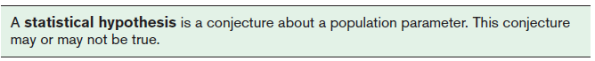
There are two types of statistical hypotheses for each situation: the null hypothesis and the alternative hypothesis.
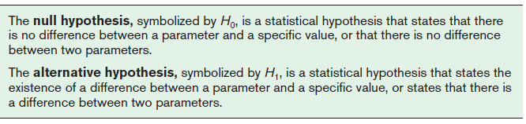
The null and alternative hypotheses are stated together, and the null hypothesis contains the equals sign, as shown (where k represents a specified number).

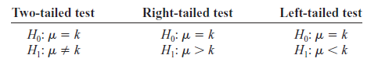
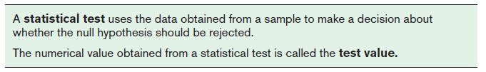

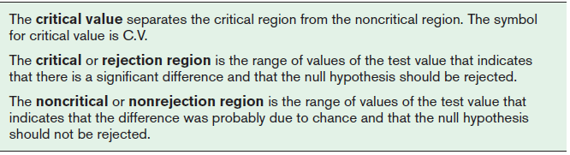

Practice Question
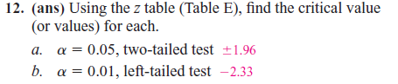
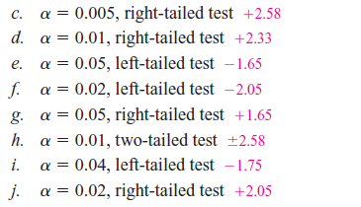
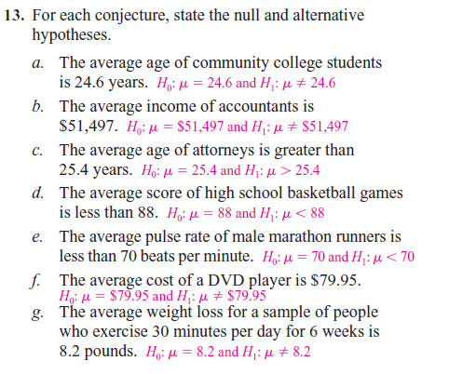

Z Test for a Mean
The z test is defined formally as follows.
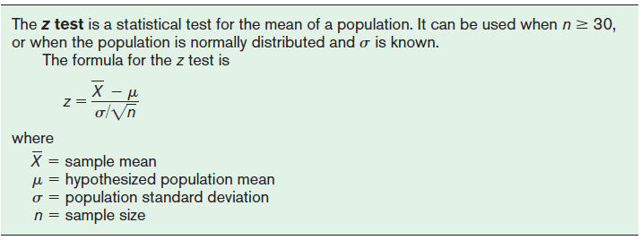
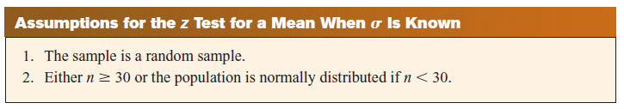

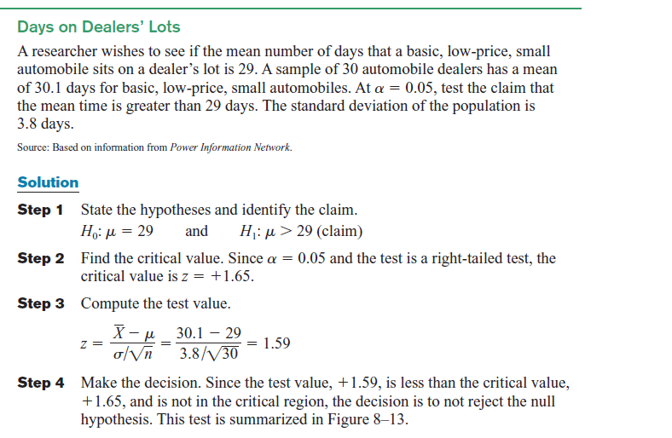
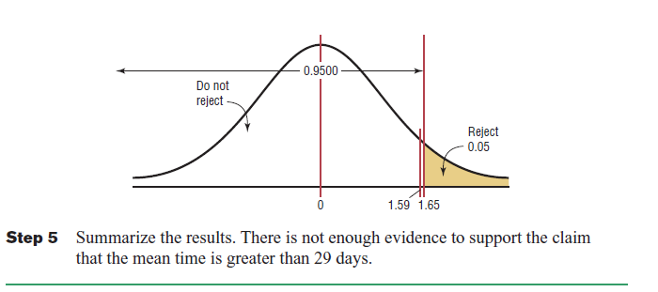
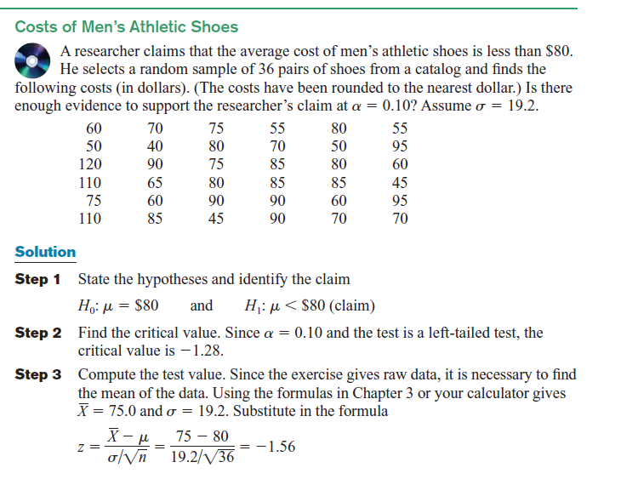
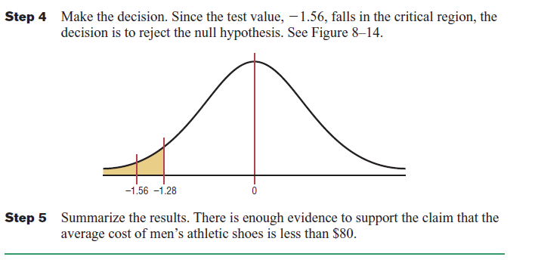
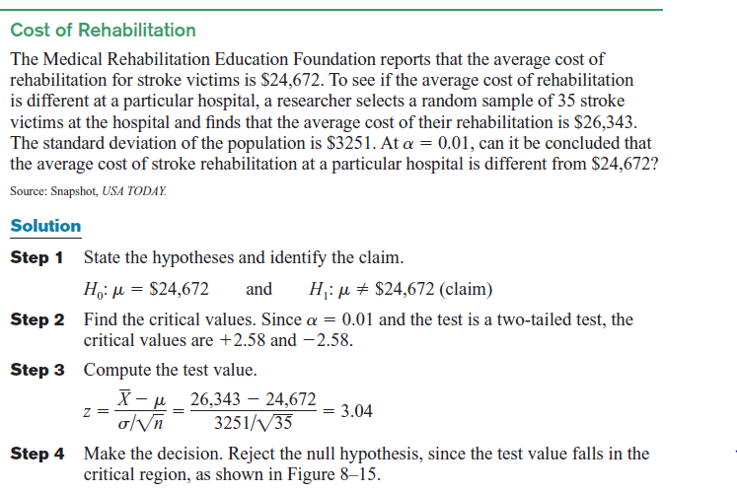
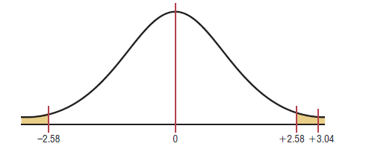
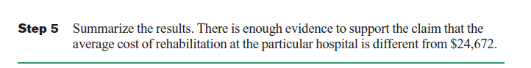

Practice Question
Use diagrams to show the critical region (or regions), and use the traditional method of hypothesis testing:

1. Warming and Ice Melt The average depth of the Hudson Bay is 305 feet. Climatologists were interested in seeing if the effects of warming and ice melt were affecting the water level. Fifty-five measurements over a period of weeks yielded a sample mean of 306.2 feet. The population variance is known to be 3.57. Can it be concluded at the 0.05 level of significance that the average depth has increased? Is there evidence of what caused this to happen?

2. Credit Card Debt It has been reported that the average credit card debt for college seniors at the college book store for a specific college is $3262. The student senate at a large university feels that their seniors have a debt much less than this, so it conducts a study of 50 randomly selected seniors and finds that the average debt is $2995, and the population standard deviation is $1100. With $α=0.05$ , is the student senate correct?

4. Moviegoers The average “moviegoer” sees 8.5 movies a year. A moviegoer is defined as a person who sees at least one movie in a theater in a 12-month period. A random sample of 40 moviegoers from a large .university revealed that the average number of movies seen per person was 9.6. The population standard deviation is 3.2 movies. At the 0.05 level of significance, can it be concluded that this represents a difference from the national average?

6. Peanut Production in Virginia The average production of peanuts in Virginia is 3000 pounds per acre. A new plant food has been developed and is tested on 60 individual plots of land. The mean yield with the new plant food is 3120 pounds of peanuts per acre, and the population standard deviation is 578 pounds. At $α=0.05$ can you conclude that the average production has increased?

8. Salaries of Government Employees The mean salary of federal government employees on the General Schedule is $59,593. The average salary of 30 state employees who do similar work is $58,800 with $σ=$ $1500. At the 0.01 level of significance, can it be concluded that state employees earn on average less than federal employees?

t Test for a Mean
When the population standard deviation is unknown, the z test is not normally used for testing hypotheses involving means. A different test, called the t test, is used. The distribution of the variable should be approximately normal.

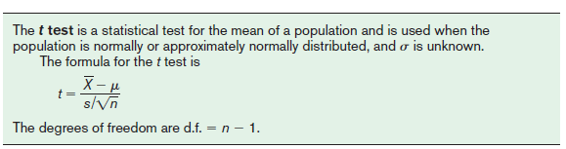

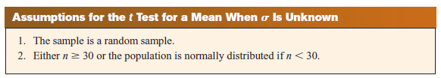
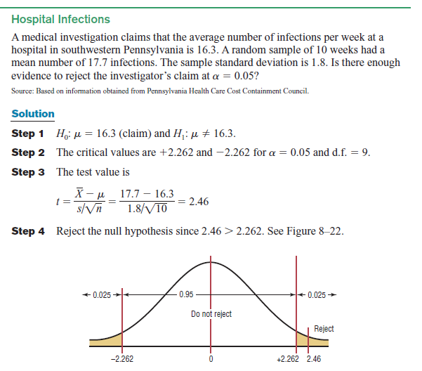

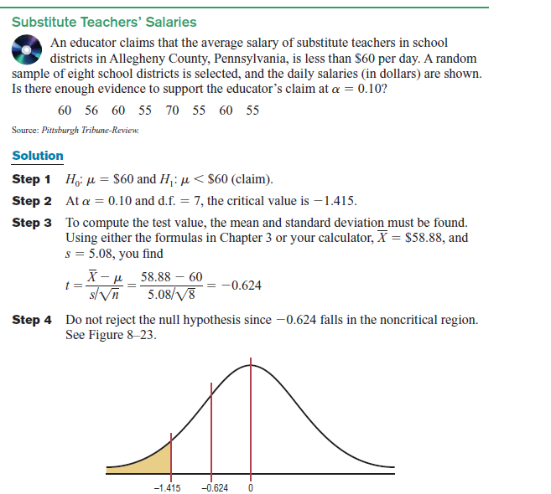


Practice Question
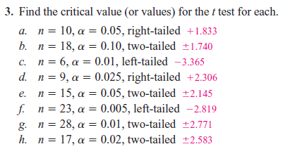
Use diagrams to show the critical region (or regions), and use the traditional method of hypothesis testing:
5. Veterinary Expenses of Cat Owners According to the American Pet Products Manufacturers Association, cat owners spend an average of $179 annually in routine veterinary visits. A random sample of local cat owners revealed that 10 randomly selected owners spent an average of $205 with s=$26. Is there a significant statistical difference at $α$ = 0.01?
6. Park Acreage A state executive claims that the average number of acres in western Pennsylvania state parks is less than 2000 acres. A random sample of five parks is selected, and the number of acres is shown. At $α$ =0.01, is there enough evidence to support the claim?
959 1187 493 6249 541
7. Cell Phone Call Lengths The average local cell phone call length was reported to be 2.27 minutes. A random sample of 20 phone calls showed an average of 2.98 minutes in length with a standard deviation of 0.98 minute. At $α=$ 0.05 can it be concluded that the average differs from the population average?
10. Exercise and Reading Time Spent by Men Men spend an average of 29 minutes per day on weekends and holidays exercising and playing sports. They spend an average of 23 minutes per day reading. A random sample of 25 men resulted in a mean of 35 minutes exercising with a standard deviation of 6.9 minutes and an average of 20.5 minutes reading with s =7.2 minutes. At $α$ =0.05 for both, is there sufficient evidence that these two results differ from the national means?

